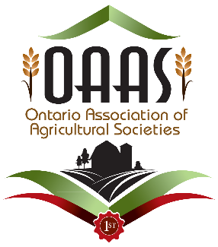
OAAS First Impressions
Application Form 2017

Name of Fair: Click to enter name of your fair.
Name of Agricultural Society: Click to enter the name of your Agricultural Society.
Fair Dates for 2017:Click to enter Fair dates.
District: Click to enter District number.
Contact Person 1:Click to enter First and Last name of Contact 1.
Address: Click to enter Contact 1 mailing address.
Postal Code: Click to enter postal code.
Email Address: Click to enter Contact 1 email address.
Phone Number: Click to enter phone number.
Contact Person 2:Click to enter First and Last name of Contact 2.
Address: Click to enter Contact 2 mailing address.
Postal Code: Click to enter postal code.
Email Address:Click to add Contact 2 email address.
Phone Number: Click to enter phone number.
Number of Days Fair Held: Click to enter number of days.
Attendance at Fair: Click to enter number attending
Fair Start Date and Time: Click to enter Fair Start Date and Time.
Fair Closing Date and Time: Click to enter Fair Close Date and Time.
Please mark off all the following categories that apply to your fair:
Livestock
Livestock classes: Yes☐ No☐
4-H Show: Yes☐ No☐
Other: Click to enter more information.
Homecraft
Hall Exhibits: Yes☐ No☐ Other: Click to enter further information.

Entertainment
Tractor/Truck Pull/Demolition Derby: Yes ☐No☐
Midway: Yes☐ No☐
Commercial Vendors: Yes☐ No☐ Other: Click to enter further information.

**NEW** - Because OAAS believes in the value of the “First Impressions” program and wishes to encourage more participation by fairs that may not be able to afford the program, once your Agricultural Society has completed all parts of the program, your fees will be refunded to your association.

A participation fee of $113.00 ($100.00 + HST) is payable to the “Ontario Association of Agricultural Societies” when you submit your application. Once you have been paired with another fair and you do not participate, there will be no refund.
In addition to the participation fee, each society will be responsible for providing passes to the visiting fair volunteers as well as their own travel costs, photocopying and /or printing and incidentals of volunteers.
Application deadline for the 2017 First Impressions program is May 15, 2017
Application to be completed and submitted online ONLY to:
firstimpressions@ontariofairs.com

